你将举办商业促销活动（trade promotion）吗？你不确定相关要求吗？  商业促销活动是专门为宣传某个商家或商店而进行的抽奖活动。例如，买一瓶可乐然后发送短信、电邮或提供你的联系方式以参加抽奖活动。  社区和慈善机构可以举行商业促销抽奖活动，但是它们需要在维州赌博及酒类监管委员会登记。  想要检查你是否登记了，请搜索维州赌博及酒类监管委员会的数据库（VCGLR database）。  如果你没有登记，你可以填写申请表（application form）。  不需要许可就可以举行商业促销活动，但是必须满足某些条件，否则会受到罚款。  想要查看完整的条件清单，请访问商业促销网页（Trade Promotions page）。  想要了解关于商业促销活动的问题并符合法律要求，请拨打1300 182 457或发电邮至contact@vcglr.vic.gov.au联系维州赌博及酒类监管委员会。  www.vcglr.vic.gov.au | 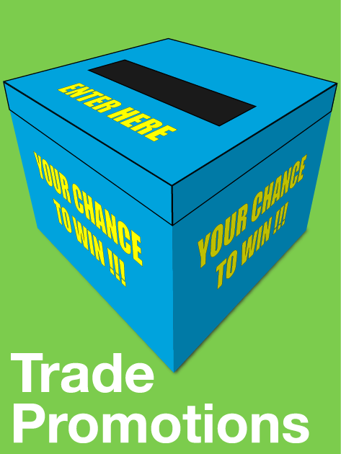
Are you running a trade promotion? Unsure of the requirements?

Are you running a trade promotion? Unsure about the requirements?
A trade promotion is a lottery designed to promote a trade or business e.g. buy a bottle of coke then SMS, email or post your details to enter the prize draw.

Community and charitable organisations can conduct trade promotion lotteries but they need to be registered with the Victorian Commission for Gambling and Liquor Regulation (VCGLR).

To check if you are registered search the VCGLR database.
If not, you can complete the application form.
A permit is not required to conduct a trade promotion but they must meet certain conditions, otherwise penalties apply.
For a full list of conditions see Trade Promotions page
For questions about trade promotions and meeting the legal requirements please contact the VCGLR on 1300 182 457 or email contact@vcglr.vic.gov.au.
www.vcglr.vic.gov.au

